Blake Richey

COSC 2336-001

Assignment 5 - Part1

1. Give the Postorder, Inorder, and Preorder traversals of the binary tree on the last page.

Inorder = LPR

Preorder = (PLR)

Postorder = LRP

Inorder: house, is your character american, dr watson, is your character a doctor, cinderella, is your character in a fairytale, batman, is your character human, godzilla

Preorder: is your character human, is your character a doctor, is your character american, house, dr watson, is your character in a fairytale, cinderella, batman, godzilla

Postorder: house, dr watson, is your character american, cinderella, batman, is your character in a fairytale, is your character a doctor, godzilla, is your character human

2)

2.1

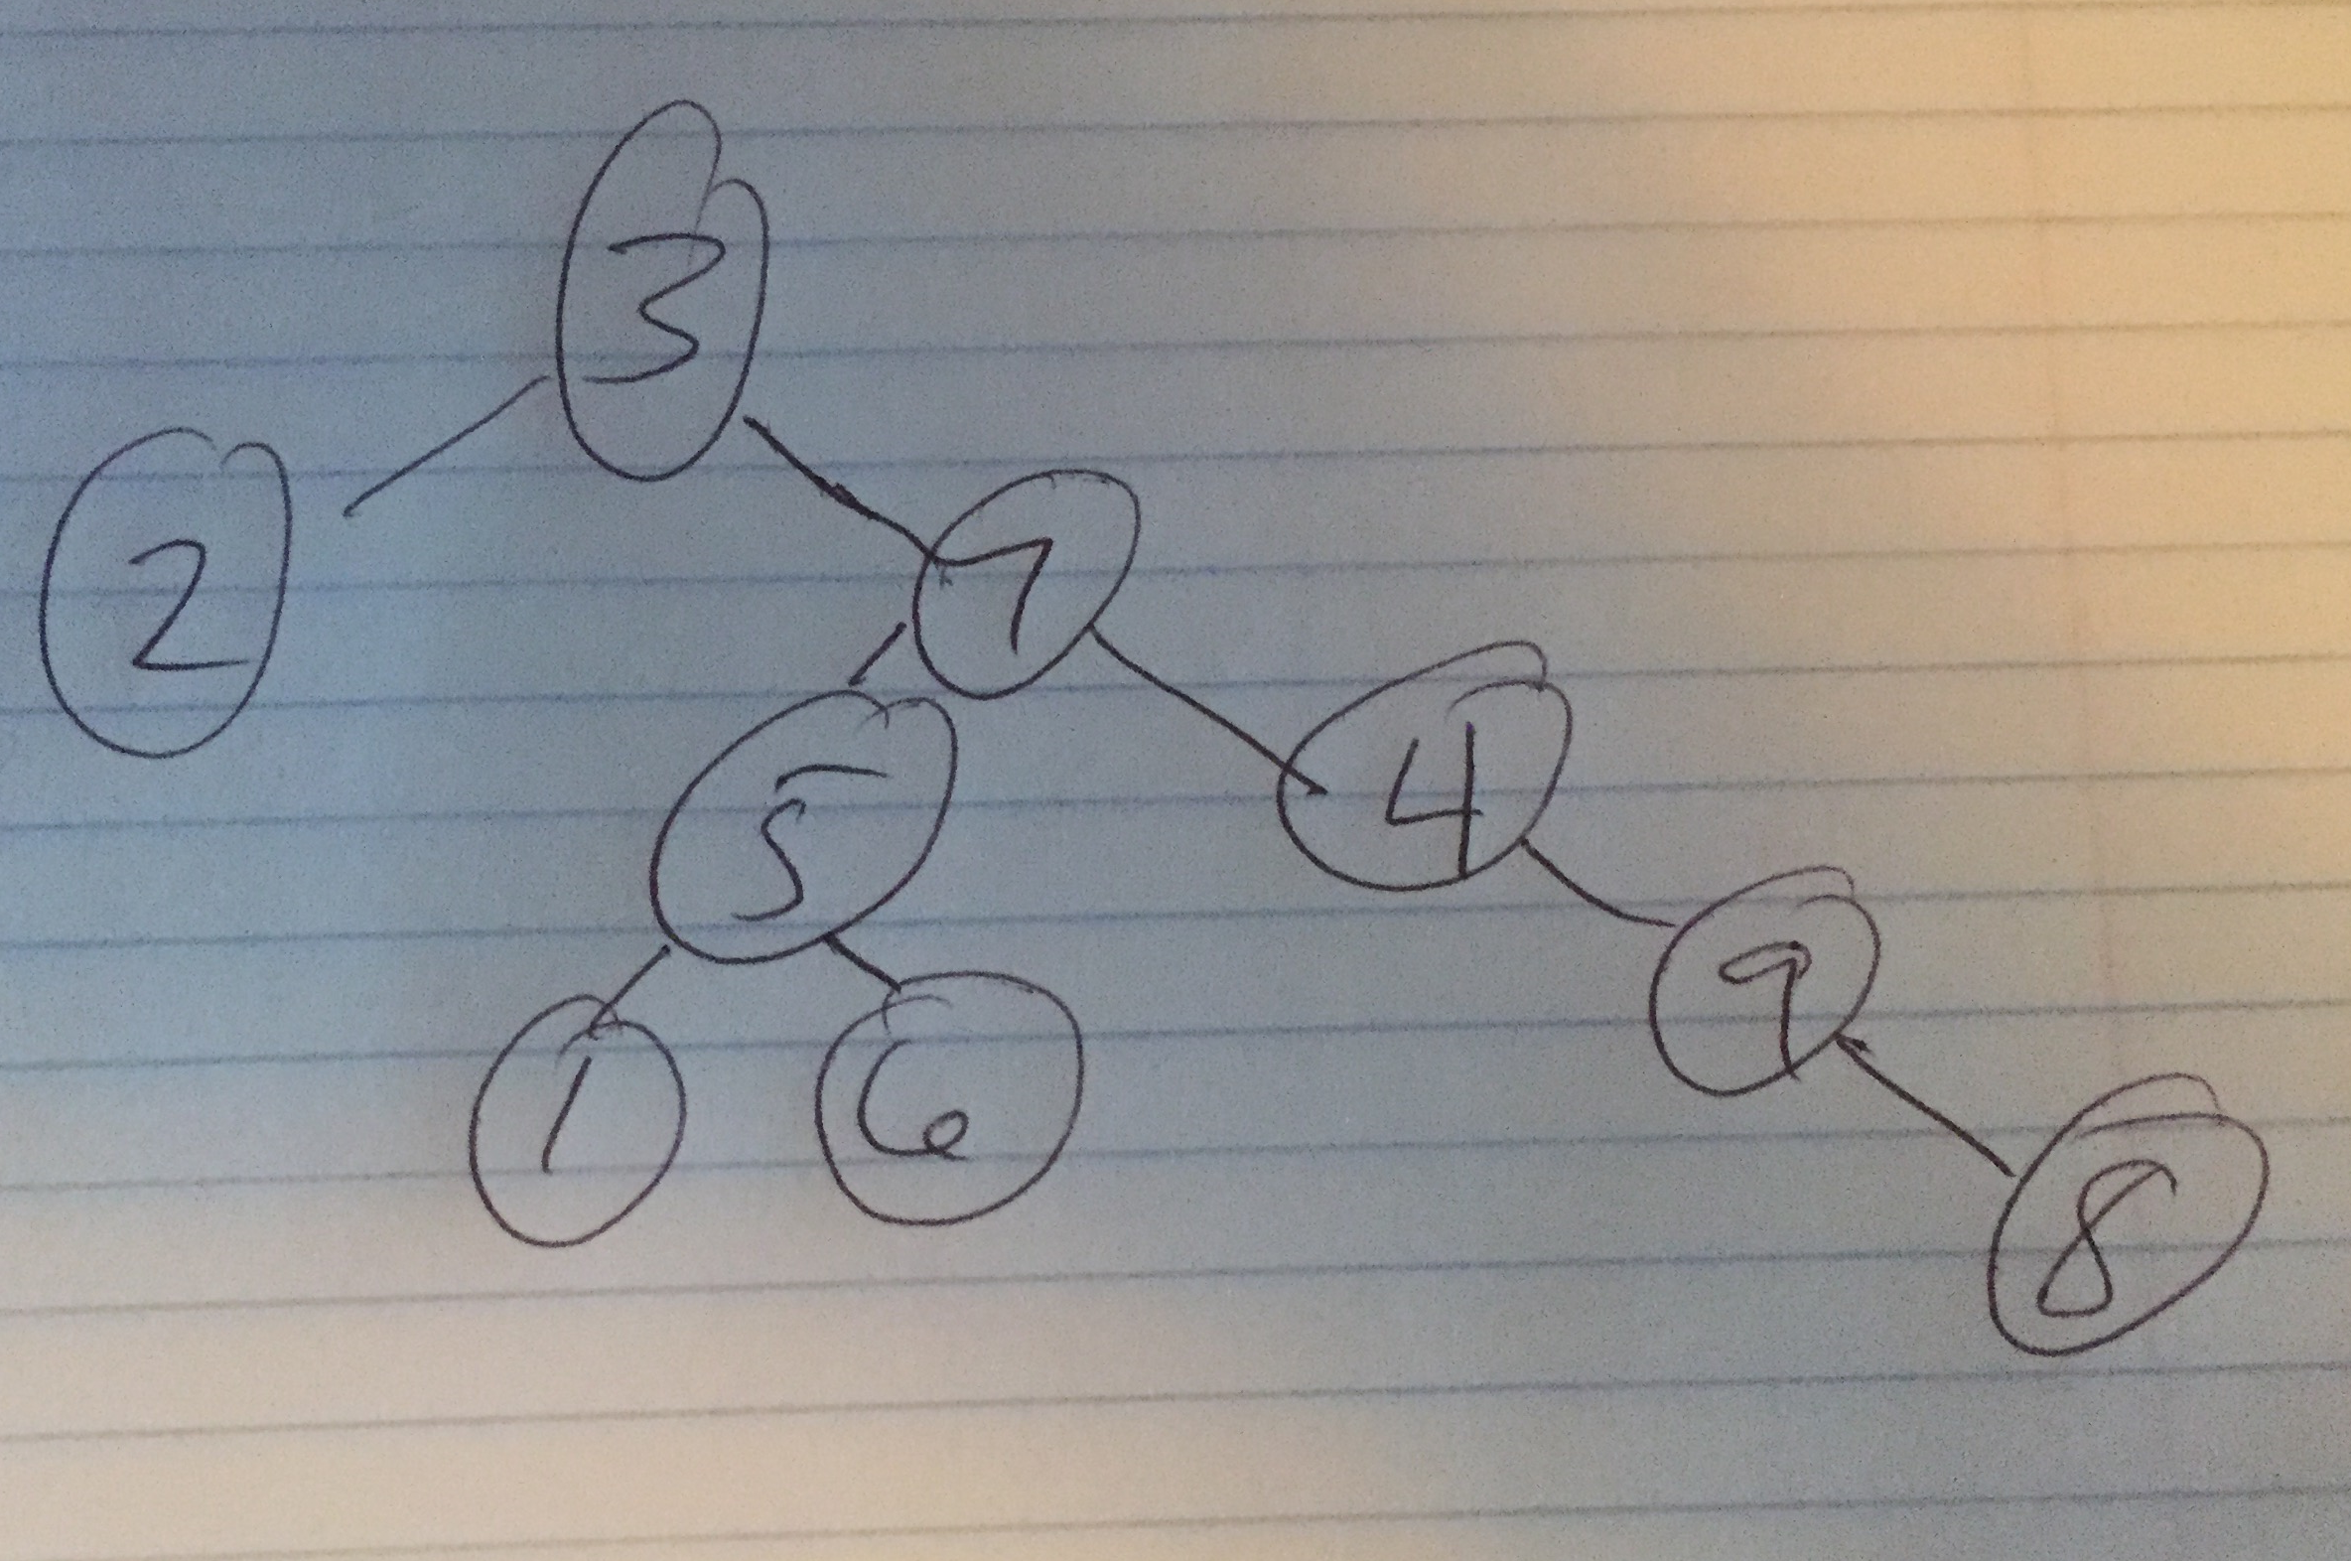

2.2

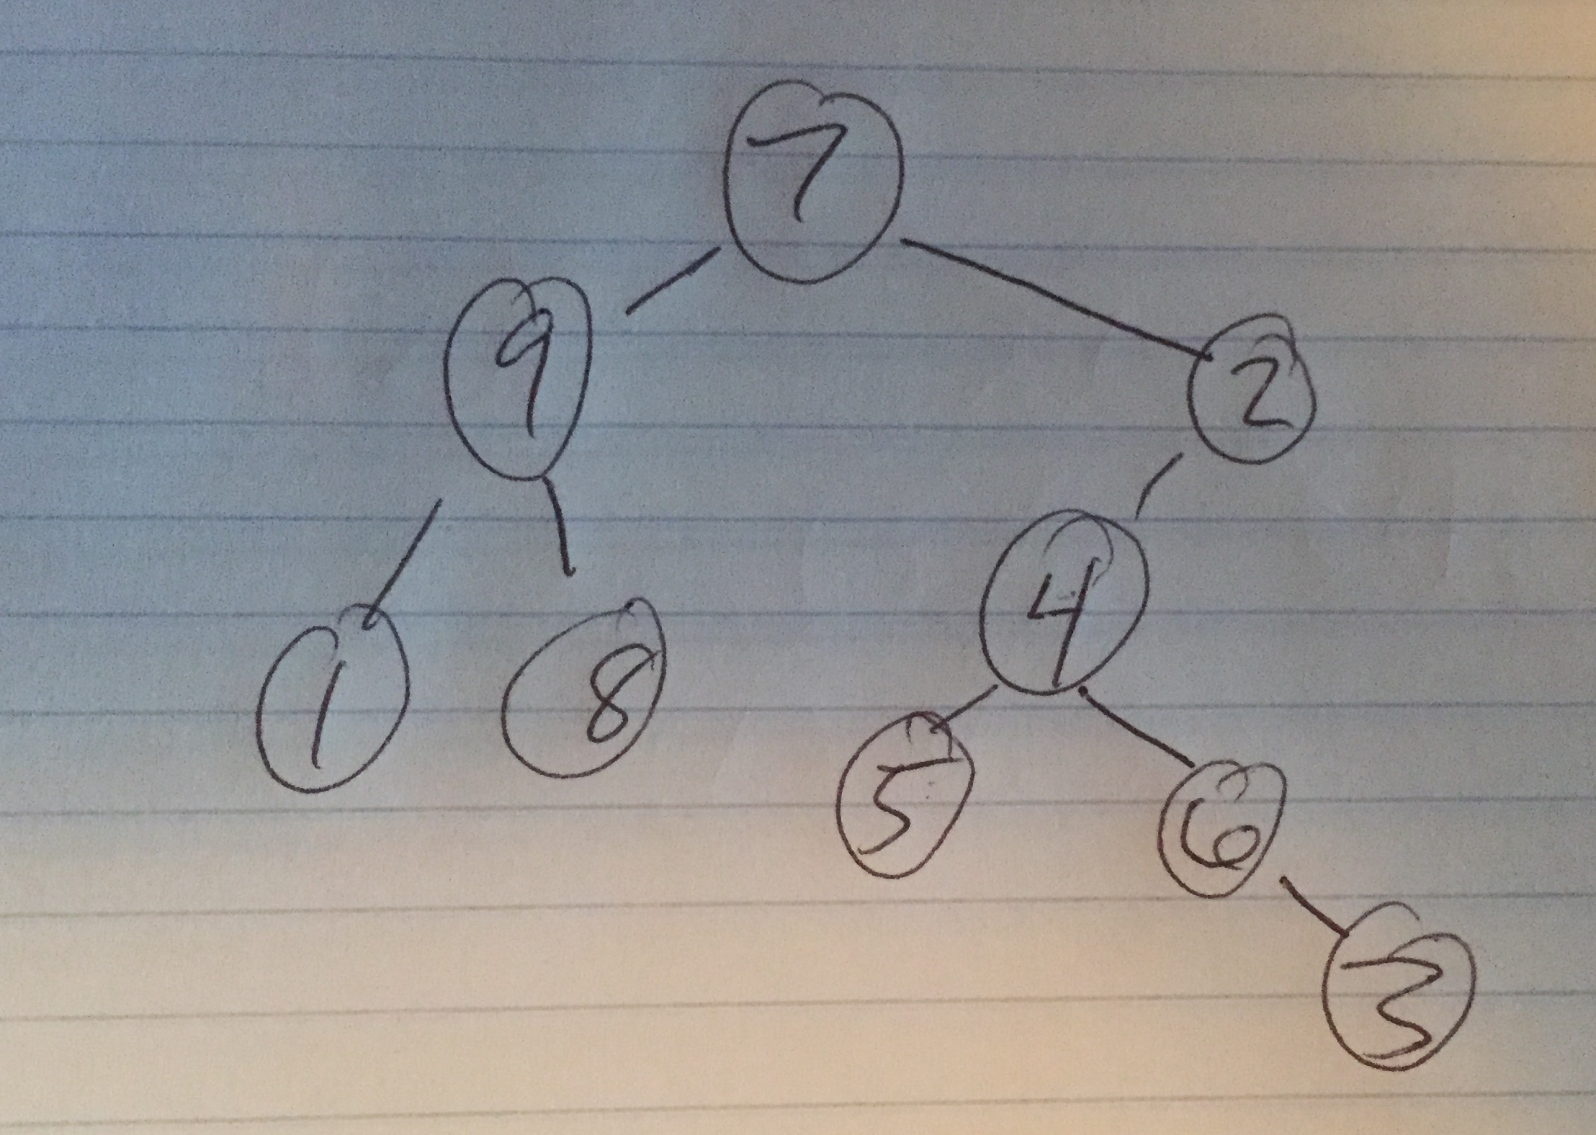

3)

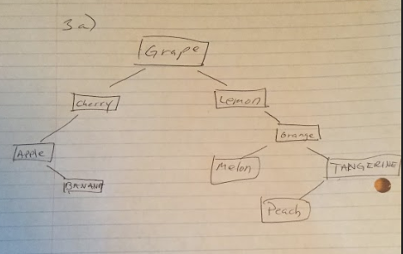

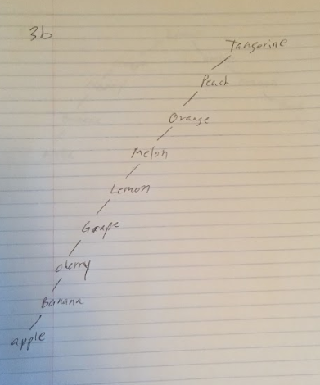

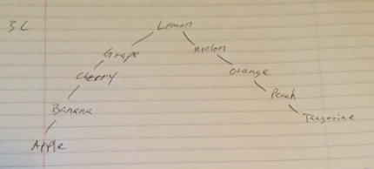

4)

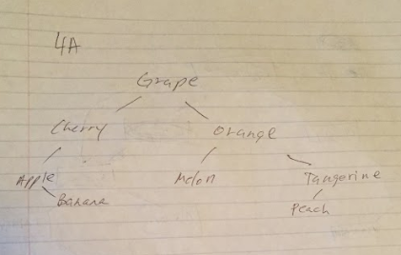

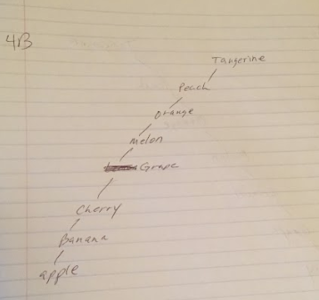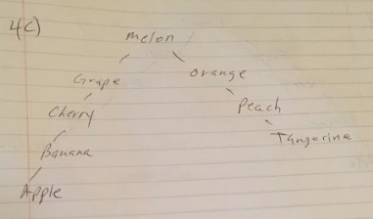

5)

5.1: is your character human?, Godzilla

5.2: Is your character human?, is your character a doctor?, is your character american?, Dr watson

5.3: is your character a human?, is your character a doctor?, is your character in a fairytale?, batman